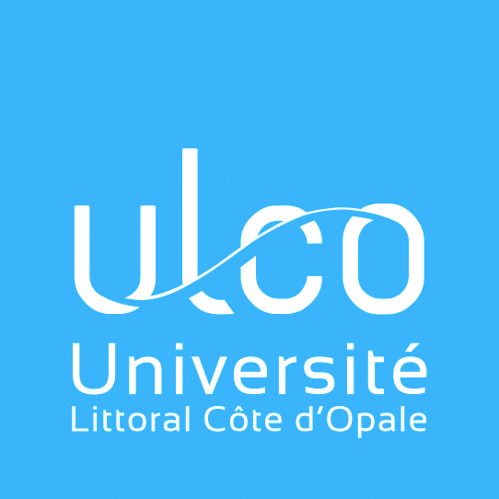

Position available for Erasmus+ internship
At the Université du Littoral – Côte d’Opale

Department: Communication Service
Position title: Student Internship / Erasmus+
Duration: Minimum 3 months, up to 6 months –
Period: Starting in January or February 2018
Location: 1, Place de l’Yser, BP 71022 –
59375 Dunkerque Cedex 01
FRANCE

The Opal Coast University (ULCO – in French : Université du Littoral – Côte d’Opale) is a public multidisciplinary university based in the Hauts-de-France region which welcomes approximately 8000 students – among which 1000 international students from 75 countries – on its campuses in 4 different cities. Boulogne-sur-Mer, Calais and Dunkirk are port cities, located on the coastline while our fourth campus city, Saint-Omer, is located in the hinterland.

Tasks:

- Translation of our French website in English (www.ulco.fr)
- Participation with our Communication and International Teams in the development of specific web content for international students.

Work Location: ULCO Central Services building at Dunkirk

We are looking for:

- A native or near-native speaker of English
- Excellent French reading comprehension (source language)
- Excellent writing skills in English
- A student enrolled at Master Level in the fields of Languages, Litterature or Communication.

Internship students receive a gratification and accommodation facilities.

Interested ? Contact Carl Vetters
carl.vetters@univ-littoral.fr
Vice-President for International Affairs, Culture and Communication

